A000-Asia-Japan-Haniwa-Warrior in Armor-Kofun Period-250 to 538 CE

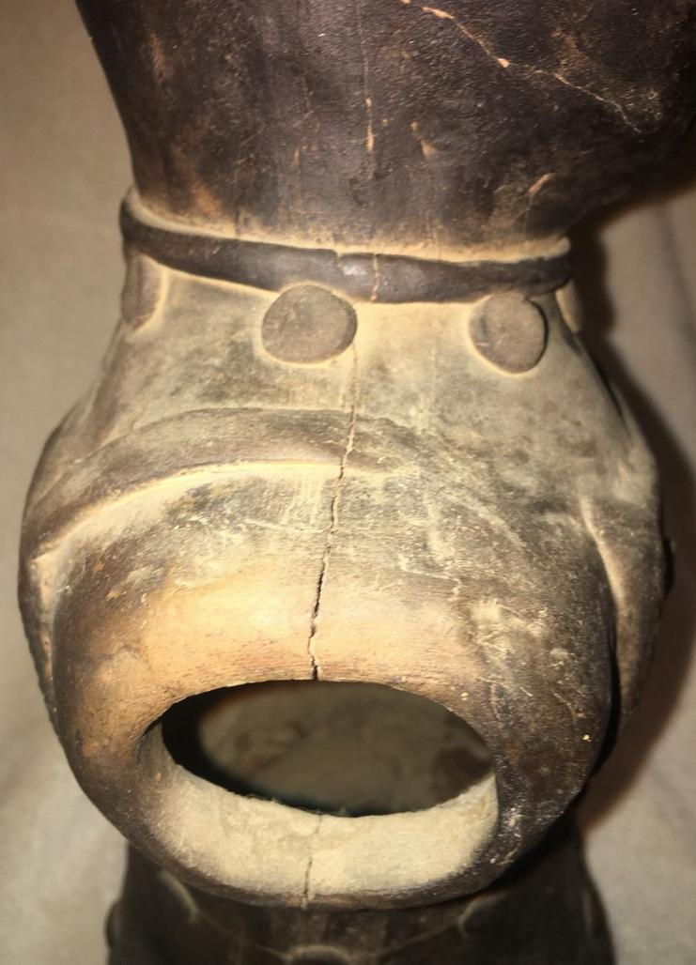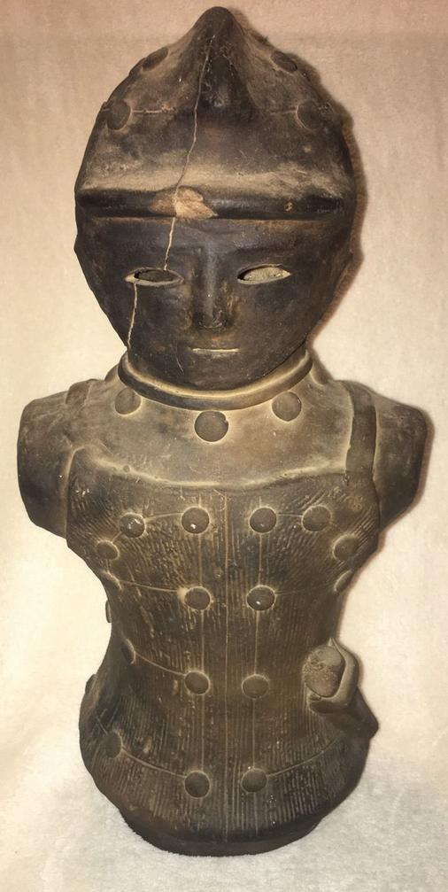 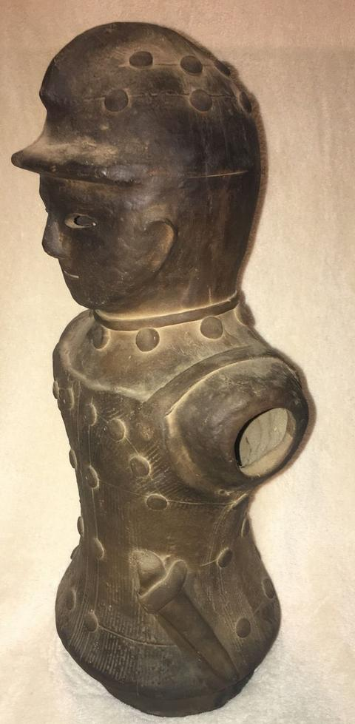 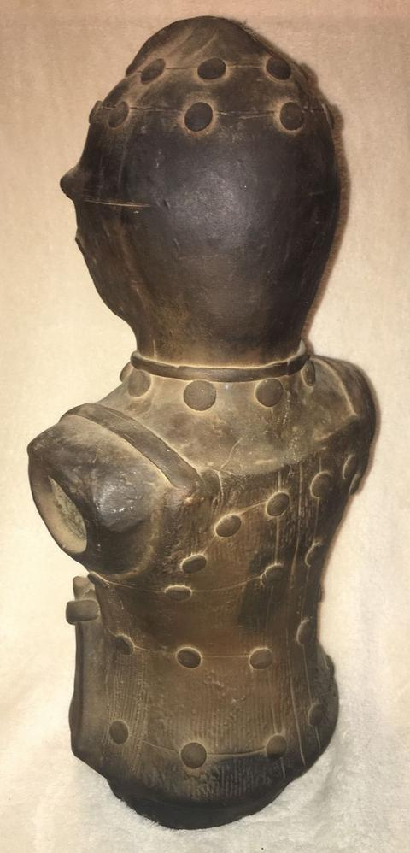 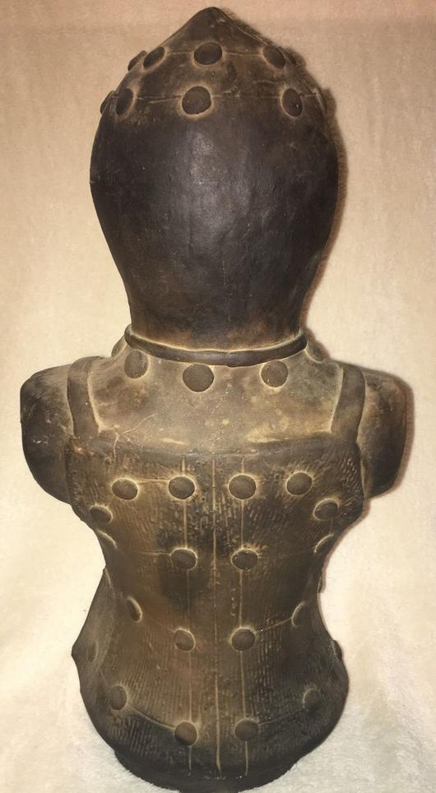 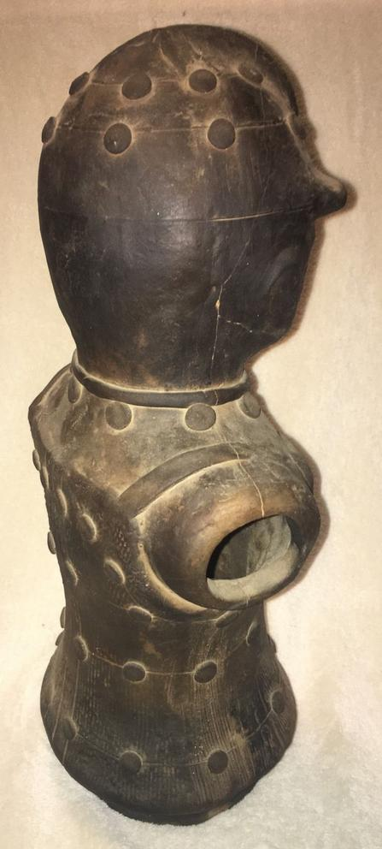 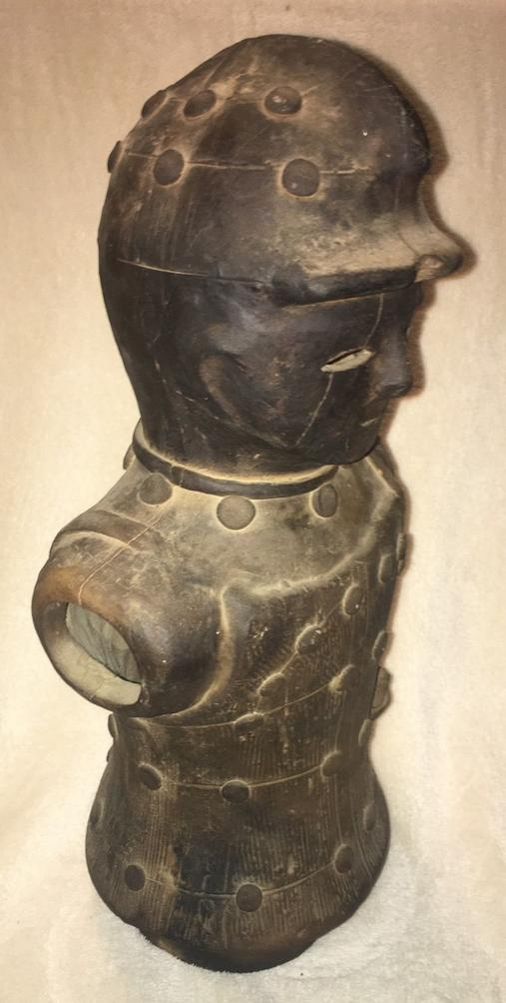 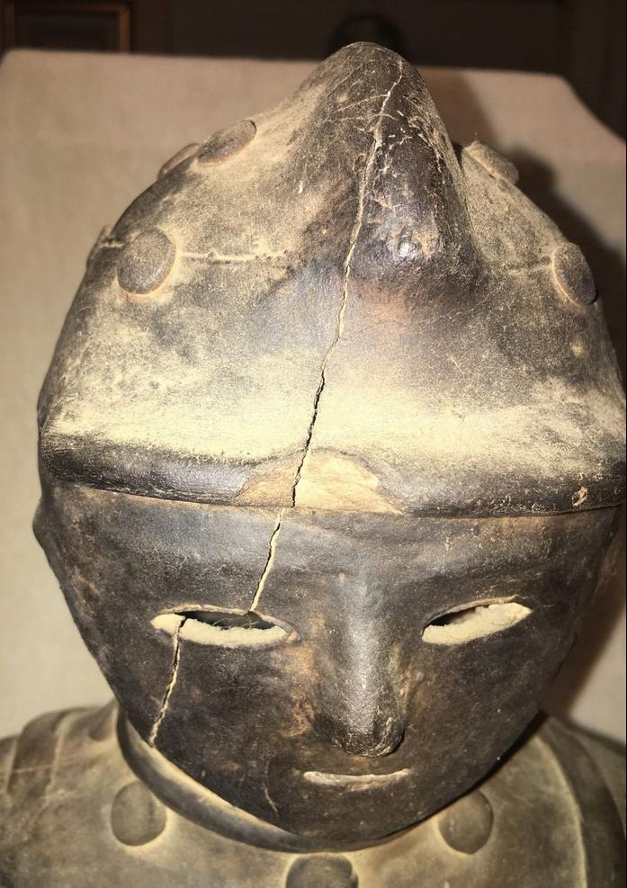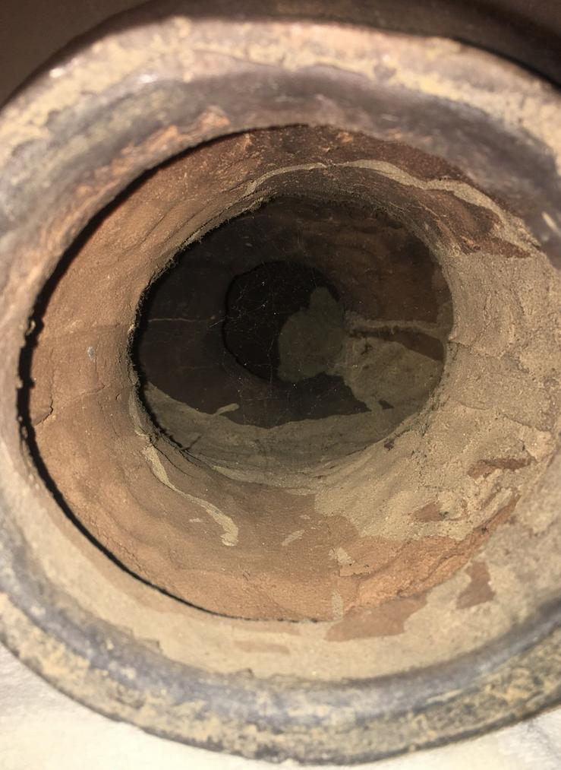

CE

Accession Number: NB 1667.A4

Date or Time Horizon: 250 to 538 CE

Geographical Area: Japan

Cultural Affiliation: Kofun Period. Early copy ca. 1900 of original from Kami Chujo Kumagai-shi, Saitama Prefecture, Kanto Region

(Miki 1961: plate 15).

Medium: Terracotta

Dimensions: 16.5 in

Weight:

Provenance: U.S. Naval Captain, Occupied Japan, 1947.

**Condition:** Mended cracks

**Discussion:** Only known figure of Haniwa warrior wearing the cuirass or corselet (*tanko*) armor, made of horizontal, overlapping iron strips riveted together.

**References:** Miki, Fumio. 1961. Haniwa : the clay sculpture of protohistoric Japan / English adaptation by Roy Andrew Miller. Rutland, Vt./ Tokyo, Japan: C.E. Tuttle, [1961]